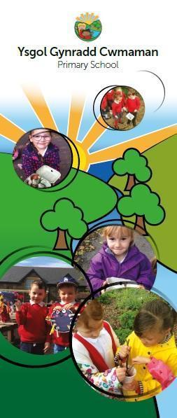

**Child Development 8-12 years**

**Information booklet**

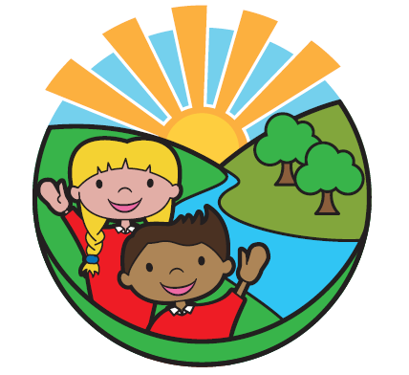

**Cwmaman Primary School**

Headteacher – Mr. P Morgan

Glanaman Road,

Cwmaman,

Aberdare.

CF44 6LA

Tel: 01685 661001

Admin.Cwmamanprimary@rctcbc.gov.uk

An overview of Child Development.

Understanding more about your child’s development may help you understand your child and their behaviour better.

Smiling for the first time, holding a toy, crawling, taking a first step and saying their first words are called developmental milestones. These are the things most children can do by a certain age. Most children’s development follows a similar pattern, although the timing of when certain milestones are reached will vary from child to child. Disabled children or children with additional learning needs may take more time to reach the different stages. If you are worried about your child’s development – ask your GP or health visitor.

Don’t try to compare your child to anyone else’s. This will put pressure on you and your child. All children are unique. Every child will develop at their own pace and in their own way. They will reach the different development stages at different times. They will also react differently to things around them, depending on their personality or temperament.

The way your child behaves is part of growing up. A lot of the behaviour you find difficult may be perfectly normal for your child's age and stage of development. Try to enjoy and celebrate your child’s changes and adapt to them.

Here is some general information about the different stages of development and some tips to encourage and support your child.

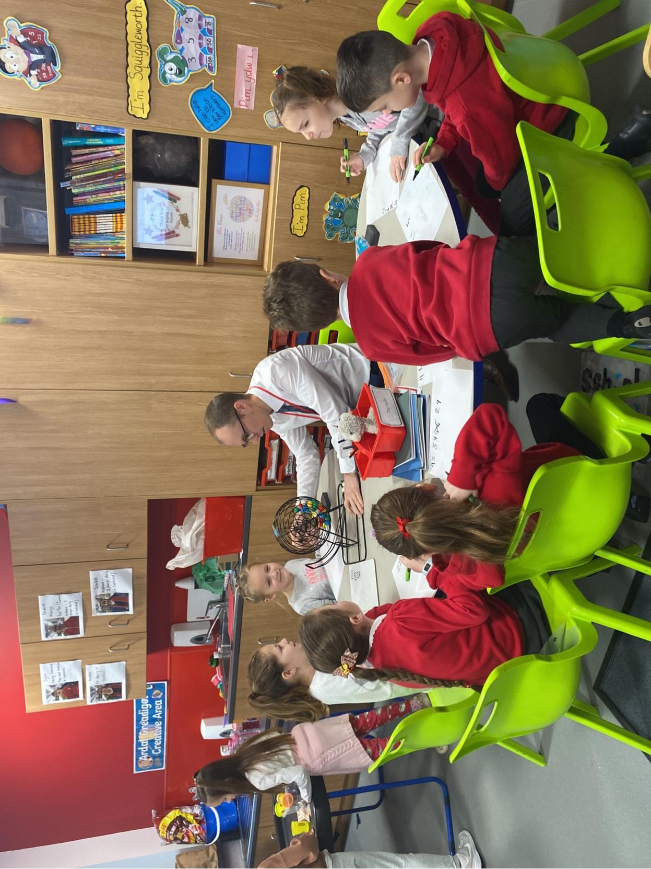

## The stages of typical child development

There is a wide variation in typical child development and you may care for children who don’t have the skills you may expect for their age. It’s also commonly thought that girls are quicker to mature emotionally than boys. However, you can use the following as a guide to milestones:

## Age 6-10

Play remains a key way of learning, but games with rules become more important as children become more confident (and also more competitive). Their understanding of the world (and the impact they have on it) is increasing. They’re learning to fit in with their peers and learning how to:

* negotiate
* compromise
* take turns
* co-operate with others.

Children of this age are developing the ability to understand how other people might be thinking or feeling and can step-in to stop behaviour they see as unfair or unkind.

They have a growing sense of their own identity (gender, racial, community and so on), which can make them very aware of what things may be stereotypically described as ‘for boys’ vs what things are ‘for girls’.

They will usually be able to cheerfully manage separation from parents/caregivers for the school day and overnight with friends/extended family and can form relationships with new people who come into their lives (teachers, peers and so on).

Their self-esteem will be strongly influenced by how good they feel they are at the things others find important (for instance school work or sports).

## Adolescent brain development

Adolescence is a time where the teenage brain is undergoing major changes. At puberty young people can lose some skills they had when younger, like certain kinds of reasoning and memory (this is why letters home get forgotten).

Teenagers find reading people’s expressions and body language hard. They can struggle to understand why people do things or how other people feel (empathy). They won’t always be able to predict the outcome of their actions (consequential thinking), which is why they do things that seem clearly risky. The brain’s reward receptors also mean taking risks is more fun as a teenager than at any other age.

Teenagers become highly sensitive to their peers’ opinions and react intensely to them. But they don’t yet have the social skills to either work out what their peers really think or how to manage their own reactions. This is why friendship groups become so important. They can have a huge impact on a teenager’s sense of self-worth and self-esteem, and can also make them feel so miserable. Teenagers are more likely than adults to upset (and be upset by) their friends, and not know why.

The teenage brain is highly vulnerable to stress and this is at a time when they have not yet developed the skills or resilience to manage it. This is why they slam doors and stomp out of rooms in tears.

So being a teenager is tough, and for teenagers in residential care, who have the extra challenges this brings, it can be especially challenging. The teenager you’re working with is not just being difficult, their brain is in the process of changing.

## Age 11-13

Puberty can start as young as nine and brings with it a host of changes. Children’s bodies start to change. This can include the following:

* girls get curvier, boys get more muscular
* they will start to grow body hair
* girls will start to have periods
* boys’ voices will drop.

At around this age children have a growing interest in sex, and masturbation is common. Hormonal changes mean they sweat more and acne can be an issue. Most children will be anxious about how they look.

They will be aware of romantic/sexual relationships and be starting to be aware of their sexual orientation although at this age this may be heavily influenced by peer group attitudes.

This is the age when some children will start to take risks. These could be positive risks, for instance taking up sports, or negative risks such as stealing, smoking or putting themselves in unnecessarily dangerous situations. Children of this age can think logically about the risks they take.

Their friendship groups take on increasing importance and children of this age can feel intensely lonely. They are also developing their ability to think for themselves and the ability to manage peer pressure.

# 

# 

# 

# Model the behaviour we want to see more of (suitable from birth onwards)

Babies and children listen to what you say and copy what you do from the moment they are born. By watching how you behave, your child will learn about how to react in similar situations. You are your child’s role model. It’s really important to notice the behaviours that we want to see in our children, so that they know to repeat these.

Tips to encourage model behaviour:

* **Show appreciation and love through words and affection**. Your child will learn to talk and act based on how you talk to them and how you treat them.
* **Give your child lots of praise when you feel proud of them or when you see a desirable behaviour.** This helps your child learn what positive behaviour looks like. Reward the behaviour with lots of attention, praise, cuddles and favourite activities. Don’t worry about praising your child too much. Make it clear to your child what you are praising.
* **Be polite and respectful when you talk to your child**. This will help show your child how to talk and interact with others. Saying please and thank you will set a good example.
* **Create family rules that apply to everyone**. Keep rules clear and simple, suitable for your child’s age and ability. Reward and praise your child for following agreed routines and rules. Use positive language to reinforce these expectations e.g. “we use gentle hands” instead of “no hitting”. Tell and show our child what we want them to do instead of what we don’t wantthem to do. For example, say “Please put your toys in the box” and show them what to do, rather than “Don’t leave your toys out”.
* **Let your child see you express and deal with difficult emotions**. When you express your anger without shouting or hurting others, you will teach your child how to deal with angry feelings.
* **Nobody is perfect**. Everyone loses their cool occasionally and says things they are sorry for. It’s okay to say sorry to your child if you have been cross. This helps children to learn that it is OK to make mistakes and how to make it right. Apologising to them or giving them a cuddle after using harsh wordshelps themto see what they can do to make it right when they lose control of their emotions. You are showing your child what to do and it will make them feel valued.
* **Using the acronym HALT**. ‘Is your child Hungry, Angry, Lonely, Tired?’ can be a helpful reminder to stop and think about the possible feelings and needs underneath the behaviour, before responding.
* **Spend quality time with your child**. Your child will love this special time with you and it is a great opportunity to chat and spend time together as a family, and will also help their development. Examples include playing a game, reading a book, or eating togetNo matter what their age, our children always need our help, support and guidance to help them make the right choices in their life.



Tips to help you support your child's development

The 8-12 age group is no exception. The transition from a young child to a pre-teen comes with a rollercoaster of challenges for both child and parents but we’ve got some useful tips to guide you along the way. First and foremost, it is so important to show your child how much you love them – they need it, want it and it gives them a sense of security and helps build on their feelings of self-worth. Like adults, children are more likely to respond better to corrections from people they have a strong connection with.

1. Remember they really do want and need your help

Your child is rapidly developing their ability to understand their environment. They are beginning to think logically and practise working things out for themselves. While they are becoming increasingly independent they are still happy to cooperate with you. They are reliant on adults and other children to learn and practise their social and emotional skills. At this time, you will still need to help your child make the right decisions, think things through and reflect on how it went afterwards.

2. Help your child to develop their own sense of right and wrong

Encourage your child to be responsible for their decisions, thinking and feelings. Affrm their ability to think logically and creatively and point out that you still love them even when they disagree with you. Work with your child and their personality to help them develop those feelings and teach them to respect others and themselves.

3. Make clear rules and stick with them

Typically a child of this age group is starting to understand, apply and insist on the application of rules in order to make sense of the world and live with others. You will frequently hear ‘it’s not fair’. This kind of testing behaviour is not a deliberate challenge and can be both positive and negative. Talk to them about what you expect and provide reasons as this will help them to think through what to do in most situations, in particular when pressured by peers. Also, allow them to be part of some wider family rules/choices, which allows them to feel included and listened to.

4. Pick your battles

Prioritise working on your child’s behaviours/problems that are the biggest cause for concern and focus only on the most important at any time. Always maintain your patience, so channel your inner Elsa (Frozen) and “Let it go”. Try to give appropriate consequences for any behaviour that is not acceptable and make sure you follow through if things haven’t worked out well, so they can see that you really mean what you say.

5. Think long term

You are raising your child to become an adult. You need to consider what personal skills they will need to become independent and reach their full potential. You need to help your child develop these life skills such as learning about being accountable for their actions, how to control themselves, being able to build themselves back up after a set-back, listening and speaking out, and understanding and respecting others.

6. Positive praise

Your child is going through big changes, they may seem to act very grown up one moment and then very immature the next. You will need to help them understand how to behave. Children respond well to praise and it will help them build up their self-esteem. They will make lots and lots of mistakes as they learn and practise, so stay focussed on this tool and praise what is going well and when it isn’t, forgive their mistakes and move on. Also praise them for just being themselves, however little it is.

7. Keep communicating

It is really important to fnd time and opportunities to listen and show you are interested in what they are saying, especially if you think there may be problems they want to tell you about. It sends such a positive message to them. During this age group, they may also start to have their own opinions and it is good to discuss these and be respectful of their opinions even if you may not necessarily agree.

8. Be clear about your boundaries

Do set appropriate boundaries and give clear instructions. Explain reasoning and involve your child in setting any rules and punishments. Abide by the rules and if they are broken let them know it is the behaviour or action you are unhappy about, not them. For example, if your child hits their brother or sister, explain how that will hurt them and explore with your child why they may have acted in that way.

9. Online safety

Make sure you know what your child is doing online. Educate yourself about the apps that they want to use before you let them download them. Teach your child about the dangers of the internet and help them to understand how they can use it safely. Make sure you use your other skills such as setting online boundaries, and keeping their equipment in a room that is used by all the family. Always keep an open dialogue with your child and encourage them to talk to you about anything that makes them worried or upset.

10. You are the role model

Parents/carers are the most infuential people in your child’s life, so don’t just tell them but show them by example. Take an active interest in your child and you will know who they are, what they are doing and who they are spending time with. It also shows your child how much you value them.

11. Practise self-control

By controlling our own impulsive reactions we develop better judgment, patience and persistence that gives us strength, stability, infuence and status as a parent. By displaying this type of behaviour, you are strengthening their understanding of what is and is not appropriate behaviour.

12. Work together

Each of you will need to negotiate and compromise with one another. Using directives i.e. ‘Do this/don’t do that‘ has two responses, obedience or defance which can create feelings of resentment, dominance, lack of respect and distance in relationships. Always work together and allow them to be part of the choices that affect them. Growing up can be a challenge to a child and they need you to be physically and emotionally present to guide and support and help them re-balance when it all feels tough and too much.

13. Identify and sustain your own support network

‘It takes a village to raise a child’ and trusted family, friends and professionals can help support both you and your child. They will offer practical help, advice or emotional support when the going gets tough.

14. Keep connected

Parents often feel marginalised in their child’s life as they become more independent, especially moving towards the teenage years. Keep communication lines open, share experiences, and remember and reminisce about past events to help maintain their sense of belonging, and retain your presence in their lives.her as a family.

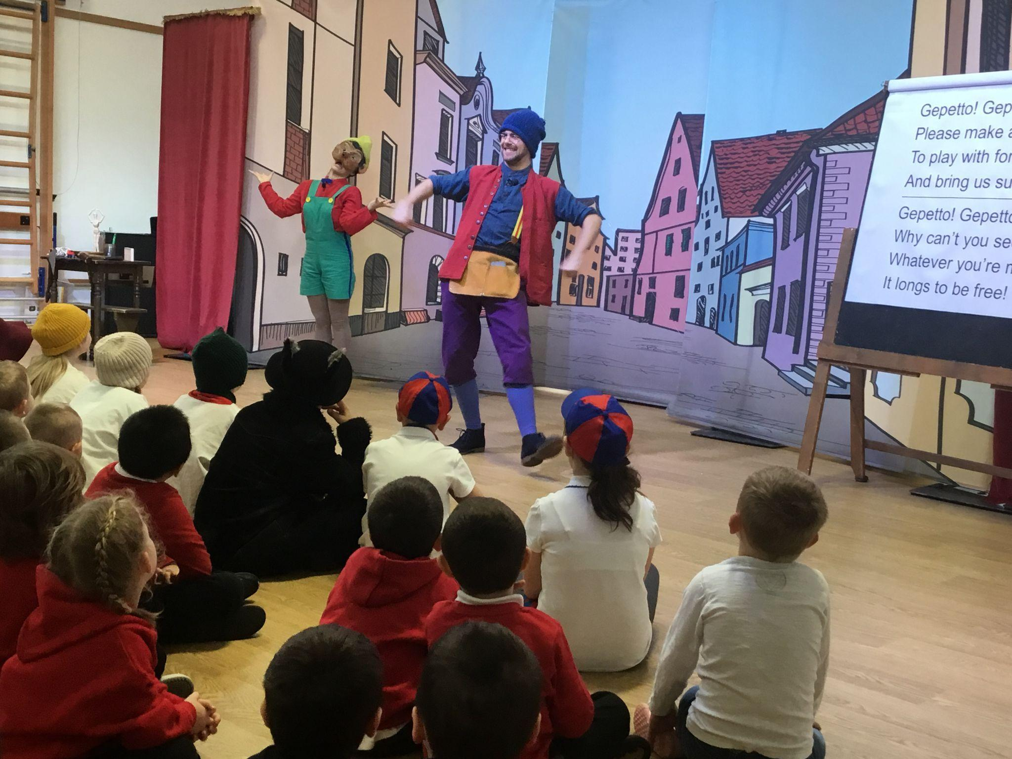 

***Helpline Support***

*Family lives: Offers a confidential and free helpline service for families in Wales on any aspect of parenting and family life. To speak to someone call* ***0808 800 2222 or*** *visit* [***Parenting and Family Support - Family Lives (Parentline Plus)***](https://www.familylives.org.uk/) *to access the live chat.*

*Parent Talk Cymru (Action for Children): Offers a free and confidential live chat with a parenting coach available in English and Welsh. Visit* [***Parent Talk - Cymru - Support for Parents from Action For Children***](https://parents.actionforchildren.org.uk/parent-talk-cymru/)*.*

**No booklet can answer every question, so please do not hesitate to call into the office if you cannot find the information that you may need. We are more than happy to answer any queries you may have or signpost you to other services that may provide help and advice.**

..