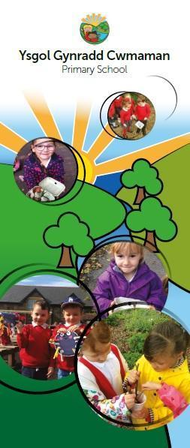

**Child Development 4-8 years**

**Information booklet**



**Cwmaman Primary School**

Headteacher – Mr. P Morgan

Glanaman Road,

Cwmaman,

Aberdare.

CF44 6LA

Tel: 01685 661001

Admin.Cwmamanprimary@rctcbc.gov.uk

An overview of Child Development.

Understanding more about your child’s development may help you understand your child and their behaviour better.

Smiling for the first time, holding a toy, crawling, taking a first step and saying their first words are called developmental milestones. These are the things most children can do by a certain age. Most children’s development follows a similar pattern, although the timing of when certain milestones are reached will vary from child to child. Disabled children or children with additional learning needs may take more time to reach the different stages. If you are worried about your child’s development – ask your GP or health visitor.

Don’t try to compare your child to anyone else’s. This will put pressure on you and your child. All children are unique. Every child will develop at their own pace and in their own way. They will reach the different development stages at different times. They will also react differently to things around them, depending on their personality or temperament.

The way your child behaves is part of growing up. A lot of the behaviour you find difficult may be perfectly normal for your child's age and stage of development. Try to enjoy and celebrate your child’s changes and adapt to them.

Here is some general information about the different stages of development and some tips to encourage and support your child.

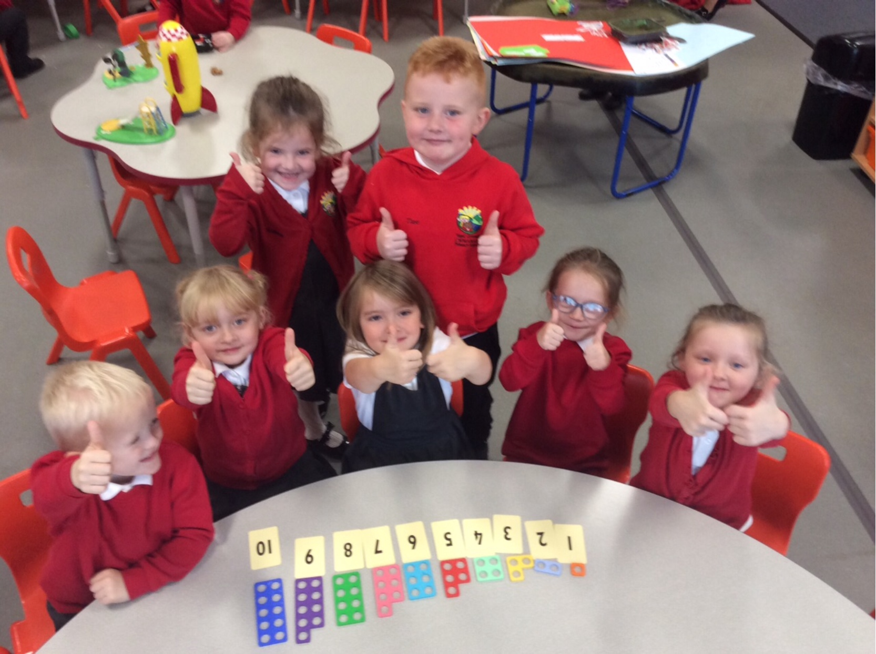 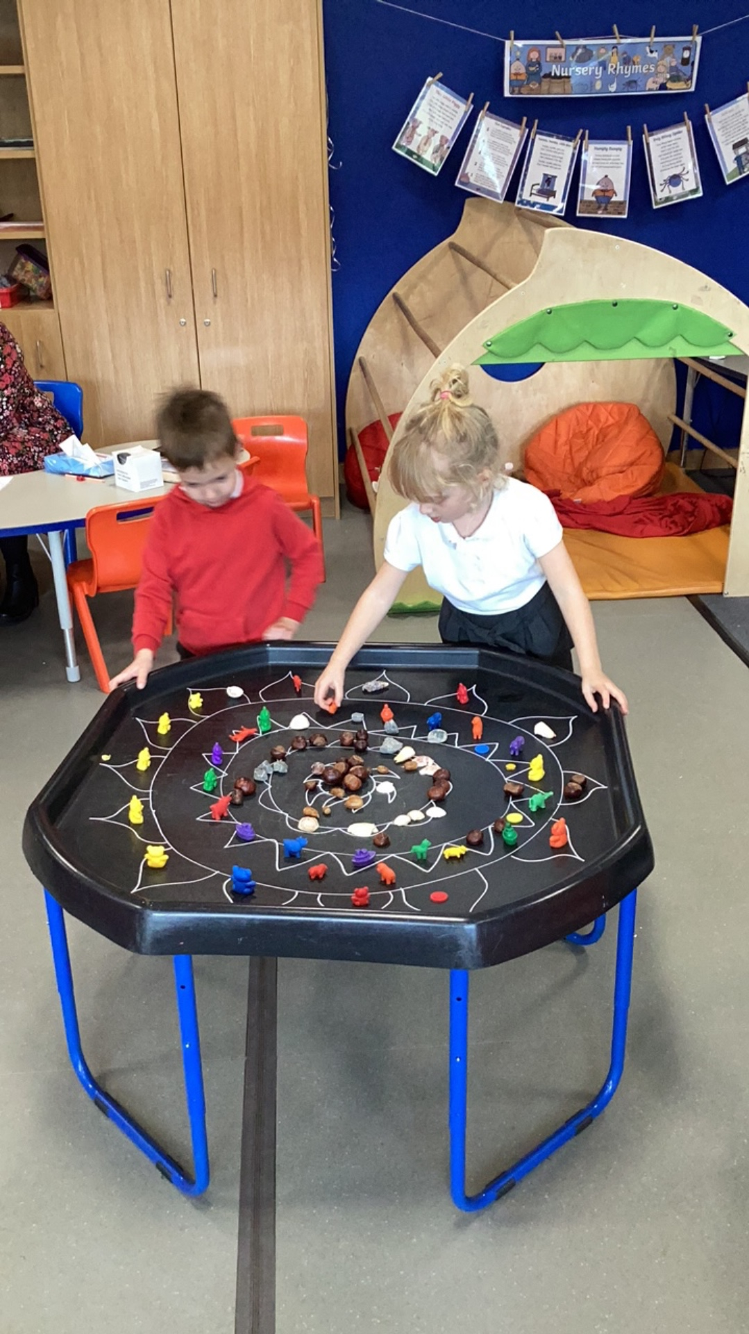

# Your child 5-7 years

**At this stage your child will be entering into their first few years of education.**

At this stage your child will be entering into their first few years of education. Watching them try new activities, cheering them on at sports day and applauding them in school plays are usually some of the high points for most parents.

At this age your child will be developing a strong sense of independence. They will be socialising mainly with children around their same age and building new relationships and friendships independent of their family.

The following provides information about these stages of your child’s development and some tips for what you can do to support your child. Your child may do some things earlier or later than suggested here.

If you are worried about your child’s development – ask your health visitor, GP or the Foundation Learning setting/school (Reception, Year 1 and Year 2)

### Between 5-6 years your child may:

* Be able to hold scissors properly and cut shapes from paper with them.
* Be able to draw more recognisable pictures such as houses, cars, flowers and people.
* Be able to write one or two letters in their name and recognise and sing along to the alphabet song.
* Start to exclude other children during play as regular friendships begin to form. They may tend towards friendships with children of the same sex. They may also feel a strong need to be accepted by their peers and feeling they are being ‘left out’ can upset them.
* Be able to write small words such as ‘dog’, ‘cat’, mum’ and ‘dad’ and recognise the difference between small and capital letters. It is normal for children of this age to write certain letters backwards.
* Remember stories and start to act them out with their toys or ask you to role play.
* Start to recognise rhymes in books and in songs.
* Eat more heartily as they burn more energy during full days in school without napping.
* Be tired and need more ‘quiet’ time to process their day; they may become more irritable for a while as they adjust to full days.

### Between 6-7 years your child may:

* Be able to tie their shoes
* Be able to count up to 100 and count a few numbers backwards.
* Be able to do some basic maths such as adding '1 apple to 2 apples makes 3 apples' and will be able to tell when numbers are higher than other number.
* Be able to give their full name and know their age, birthday and where they live.
* Be able to start making up rhymes and enjoy simple jokes.
* Have an average vocabulary of over 5,000 words.
* Be able to read up to ten easy and familiar words, such as 'cat' and 'dog', and read some simple books. They may be able to copy short words and write some familiar words without help.
* Be able to hop on both legs, skip, jump with both feet, walk steadily on low walls or beams, catch a ball with their hands rather than their arms, and may be able to ride a bike with or without stabilisers.

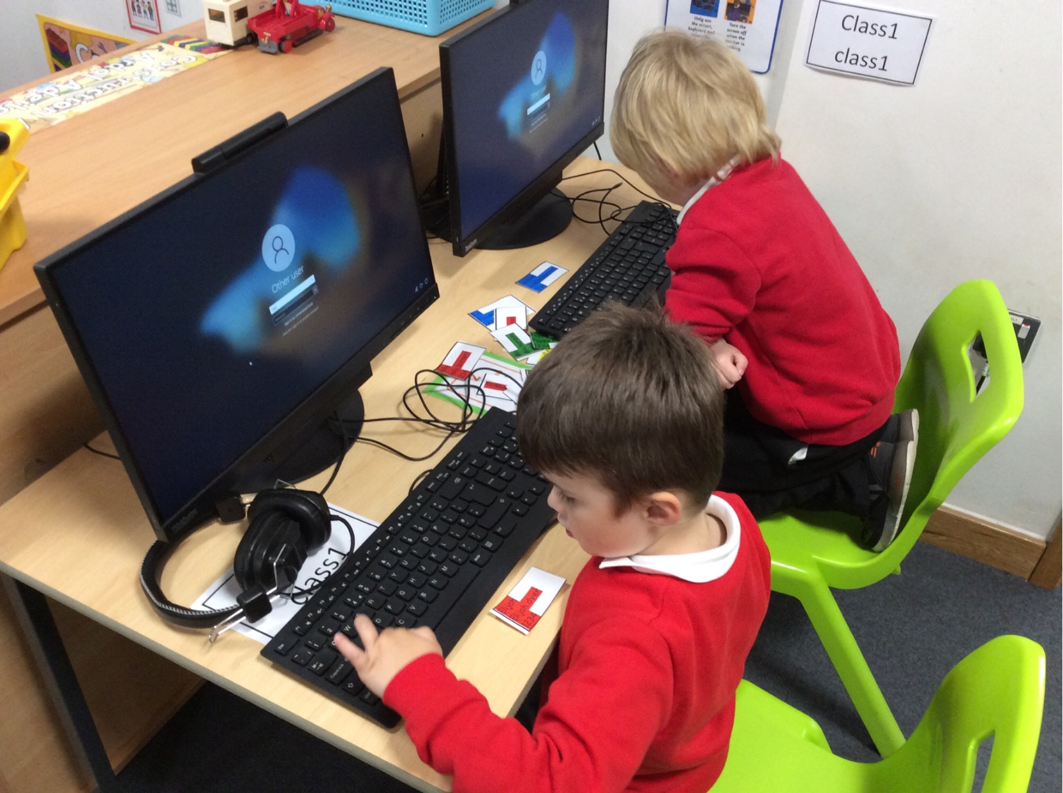

### Tips to encourage and support your child's development

* A day at school can be tiring for your child and can lead to some grumpy behaviour. Giving your child lots of cuddles, individual attention and encouraging quiet, calming activities may help. You may also want to consider setting consequences if they are not behaving as you would like them to.
* Show an interest in what your child has to say. This will let your child know they are important to you. Encourage them to talk by using open questions like “Tell me the best thing about your day?”
* Ask them to make up new endings to their favourite stories to help with their creative thinking.
* Try to stick to routines and visit familiar places which give your child security. They will be introduced to so many new challenges and will take comfort in the safety of things they feel familiar with.
* They will start to lose their baby teeth so it’s important to see a Dentist every 6 months and encourage a healthy brushing routine twice a day.
* Encourage them to be more active by taking part in an activity they enjoy such as football or swimming. This will help them to keep healthy, to sleep better and to enjoy being active from a young age which will help them as they get older.
* They are still developing and learning how to fit in. Tantrums, anger and frustration will still happen; this is completely normal.
* Talk to your child about their feelings. This helps them put words to these feelings.
* Try to set aside some time for play as it is still very important at this age. Let your child choose how they want to spend this time and take the time to join in. This will give you the chance to enter their world and find out what they are thinking and feeling.
* Try to make play time work for you when things get busy. Get them to help you with simple tasks like tidying up, putting away clothes, or laying the table, maybe do this to music or when singing. Getting them to help out around the house will help them to feel grown up and can support positive behaviour.
* Try to reduce the amount of time spent in front of the television or on tablets and phones. You can spend time with your child by using Apps that develop their skills. The National Literacy Trust have a wide range of free Apps to download [**http://literacyapps.literacytrust.org.uk/**](http://literacyapps.literacytrust.org.uk/) (External link)

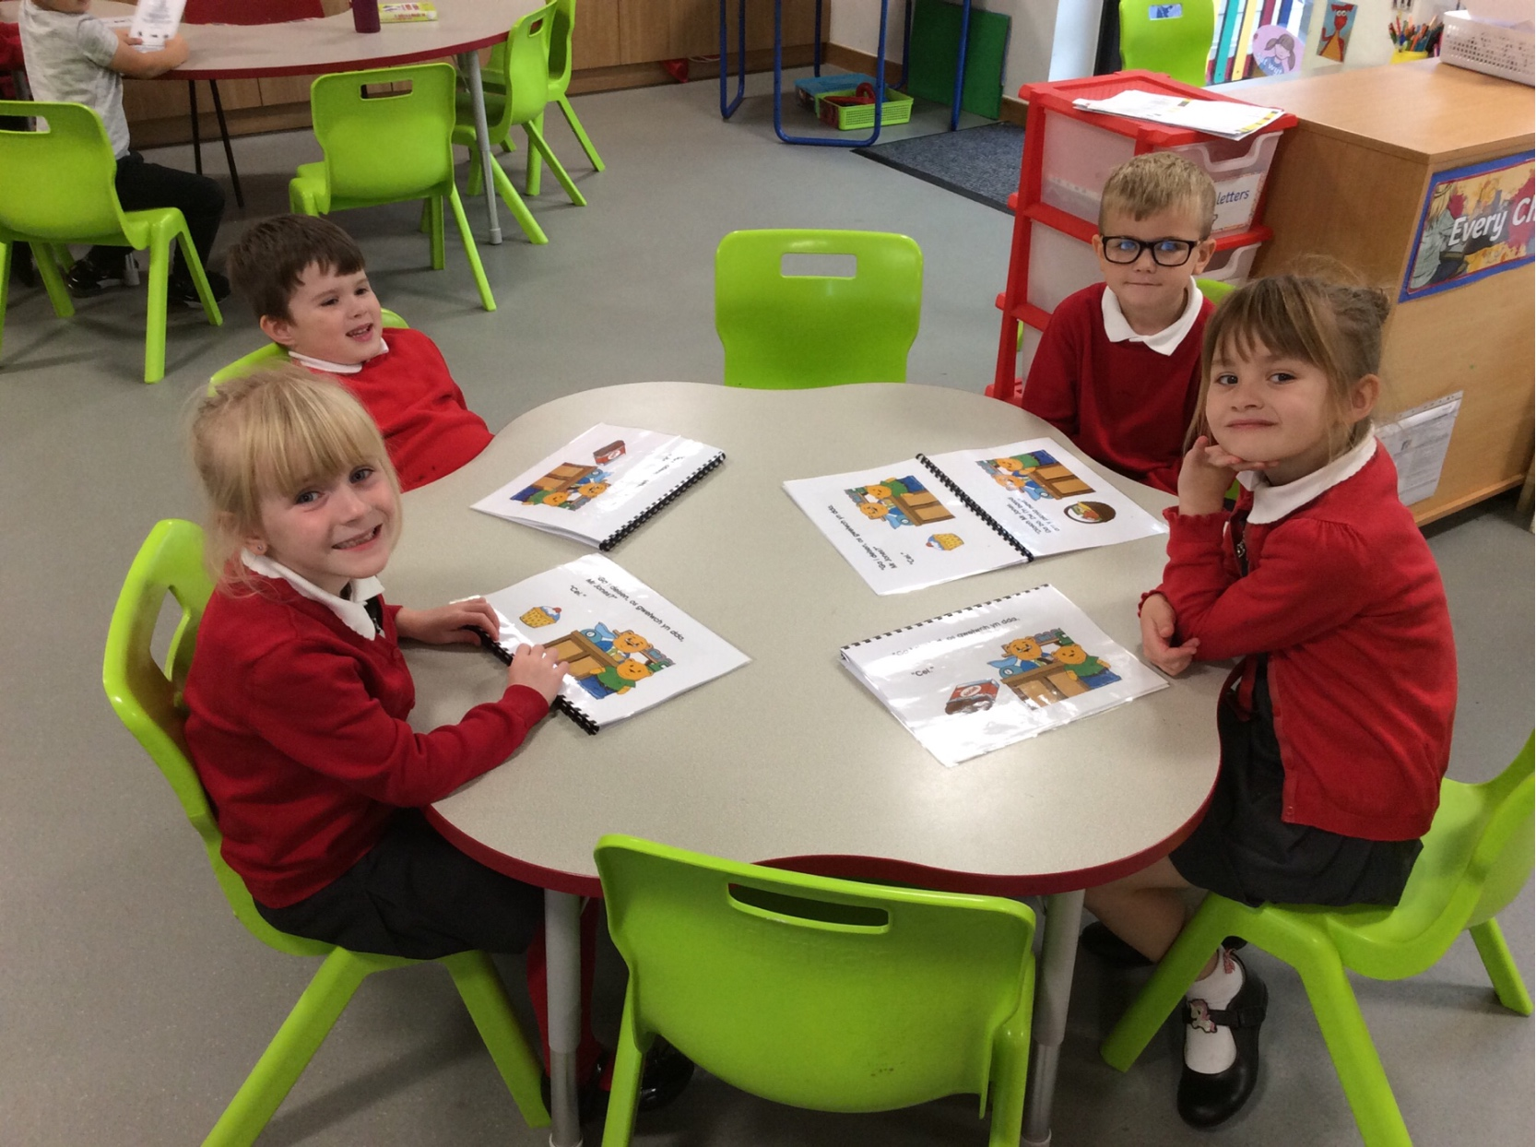

Ten tips to help you support your child's development

### 1. Simple, regular routines

These will help you and your child feel more secure. Routines will help structure your day from start to finish. You will need to plan ahead for the next day and week but keep it simple and doable – getting up time, meals, bath time, exercise, and going to bed.

### 2. Talk about what you’re going to do

Talk about and explain to your child what you are going to do throughout the day. Help them take turns in conversation. Tune into what they already know and build on their daily routine. Be a running “commentator” and keep your language simple. Draw pictures, show pictures or use objects to show what you are going to do if your child needs more help to understand. If you have them, use photos of friends and/or family to talk about people that are important to you in different households.

### 3. Enjoy your time together

Have fun, we learn best when we are enjoying what we do. If you or your child are not enjoying something, stop and change your plan. Try to make sure you do something fun for you and your child every day, more than once if you can.

### 4. Selectively use devices

Use the TV and/or other devices, but choose when you are going to watch and what you are going to do. CBeebies and S4C's Cyw have some fun programmes. Use your phone/other devices to record what you have done – kicked a ball, learnt a new song or a new word. Turn off the TV when you are not watching it so there is not a constant stream of information.

### 5. Use what you have at and near your home

You don’t need to buy extra things. Walk in your garden or near home, point to flowers, birds and trees, buildings and everyday objects and name them. Play walking, running and finding games. Do a treasure hunt for everyday objects in your home/garden. Teach your child a new song or nursery rhyme. Play catch, or rolling a ball backwards and forwards. Use mirrors in the bathroom to encourage copying and taking turns – making silly faces. Children like to repeat familiar activities. You are your child’s first and lasting teacher – you can help them learn and grow so much. They can also teach you - look at how they learn best.

### 6. Let your child join in and help as much as they can with household tasks

Cleaning, cooking, fixing. If they can’t help, they can watch you and you can tell them what you are doing. If you have older children, they may be able to help by talking with and/or entertaining younger siblings.

### 7. Create a safe, quiet place for your child to be quiet

A cocoon. Create the same for yourself. Put your phone in the drawer and check at set intervals only (not too often). Acknowledge your worries, ask for help/advice if you need it and let your child ask for help. Practise relaxing and deep breathing.

### 8. Let your child talk and ask about COVID 19 and other things that may be worrying them

Covid 19 is still around us and if your child wants to talk about it please tell them the facts very simply. They may also be worried about the war in Ukraine or having enough money. Let them tell you about their worries, however small or big.

### 9. Keep in touch with your family and friends

This could be on a daily basis or a few times a week either face-to-face, or by FaceTime/Skype/WhatsApp if they live away. Start by saying “Hello” and finish by saying “Goodbye”. Tell or show your family one thing your child has done well or learned. Decide what you will share/do, sing a song or do a dance. If you need a longer chat for yourself ring later when your child is asleep, if you are not too tired!

### 10. Celebrate achievements

At the end of each day, think of one particularly positive thing that you and your child have achieved and enjoyed that day. Tell them, talk about it and record it in some way and celebrate it.

For more information and advice on parenting, visit: [**gov.wales/parenting-give-it-time**](https://gov.wales/parenting-give-it-time)

Keep in touch with your Health Visitor. They are here to help you and your family.

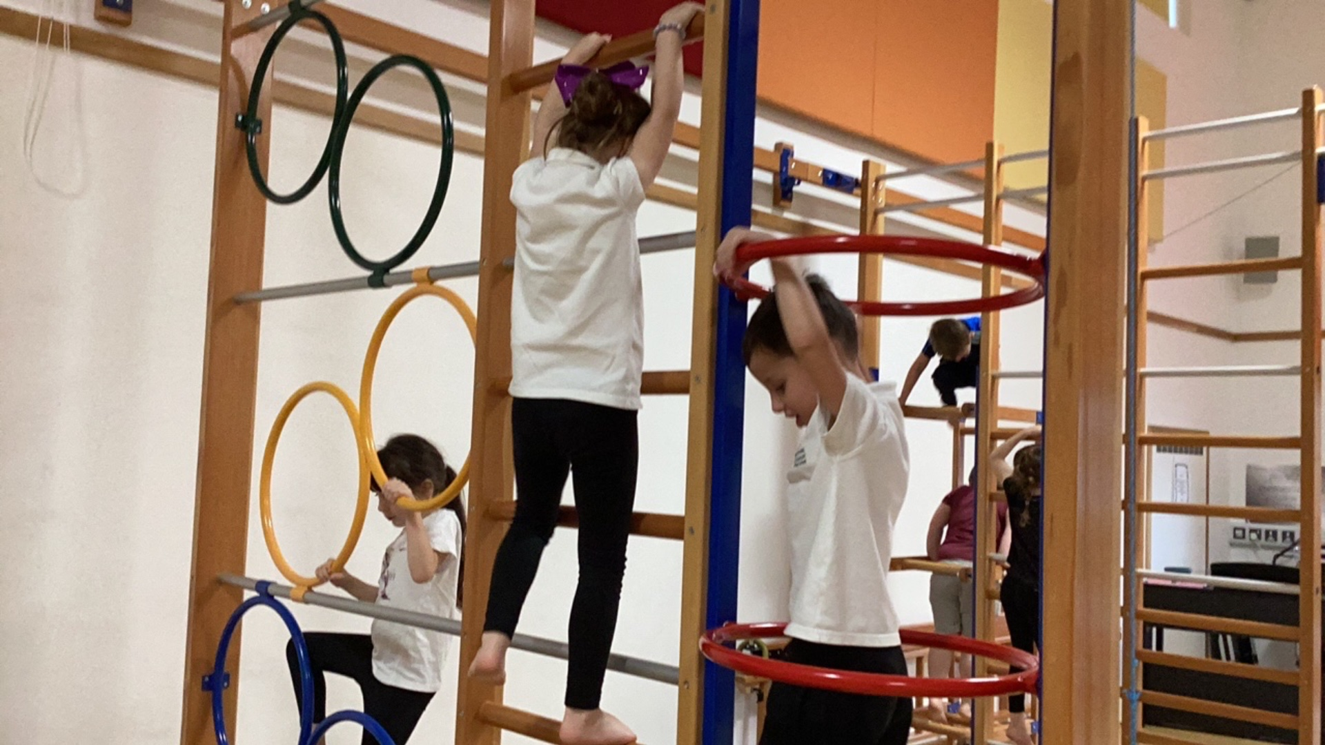 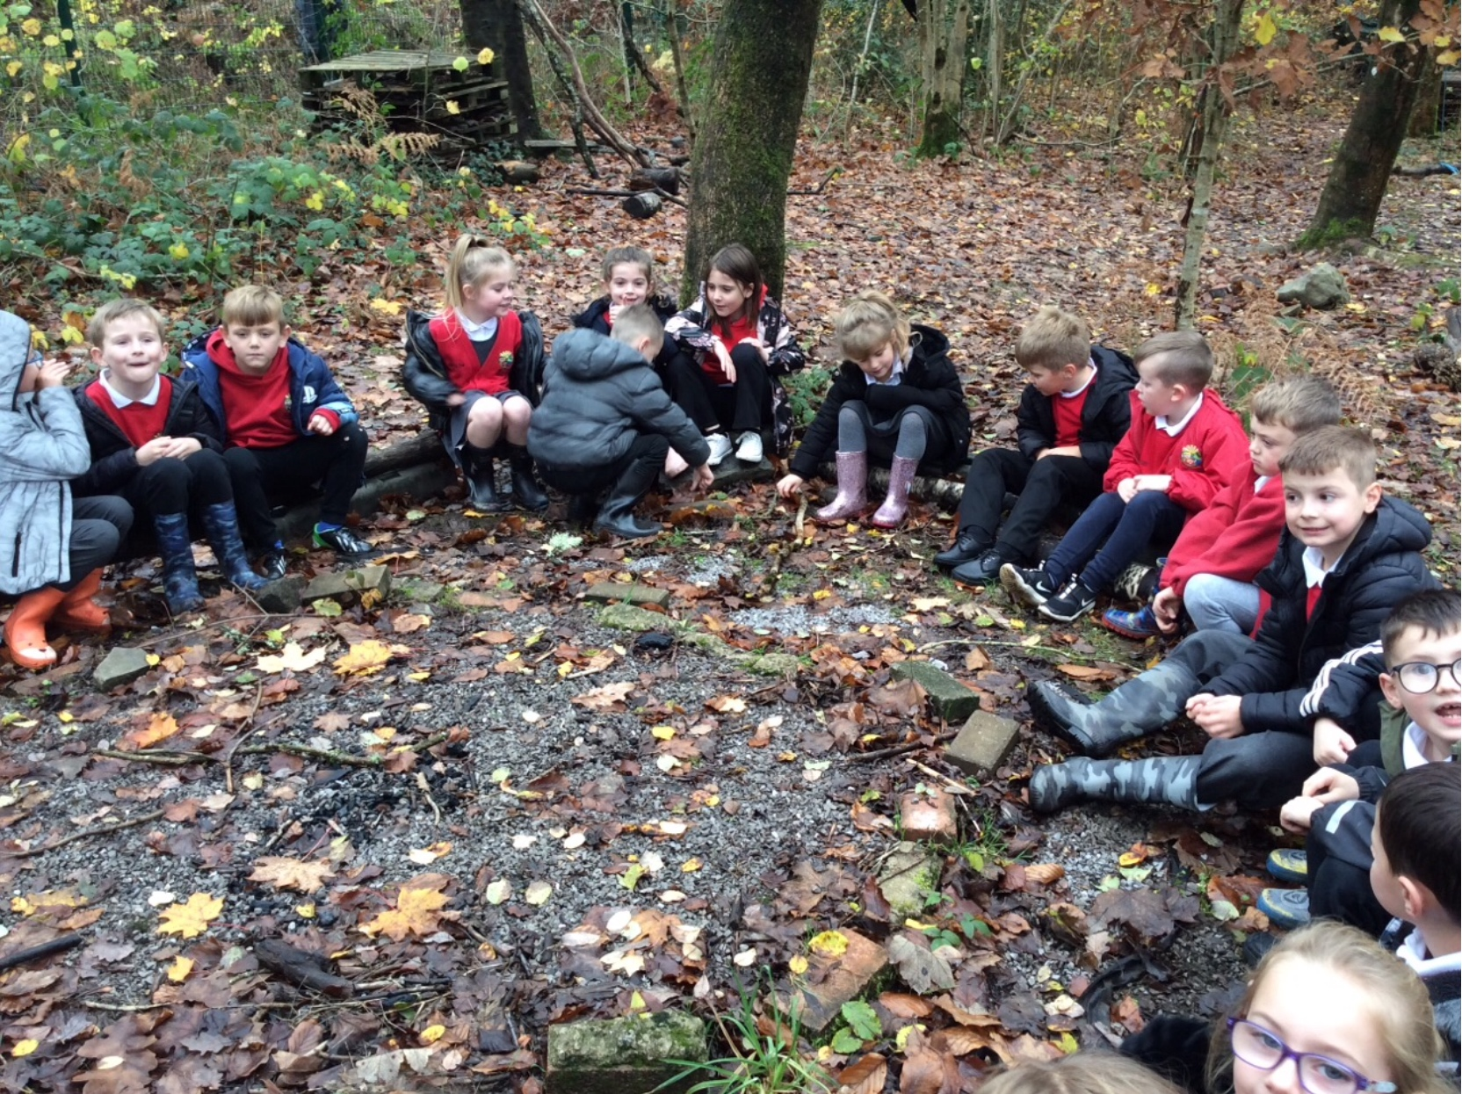

# Understanding and responding to behaviour: 4 to 7 years

Children's behaviours are very much linked to their stage of development. Their brains are still developing rapidly in the early years and some of the behaviours that younger children display are outside of their control. Parents or caregivers can help children to learn how to understand their emotions and develop more control over their behaviours by helping them to develop an important set of skills called self-regulation skills.

Developing self-regulation skills takes time. Every child is unique and the development of these skills is a mixture of a child’s individual differences and their environment. A big part of this environment is the interaction and relationship they enjoy with their parents or caregivers. When parents or caregivers are faced with these behaviours it is important to respond in ways that help in the moment, but also help our child to develop self-regulation skills.

Using punishment to respond to a child’s unwanted behaviour might result in a ‘quick fix’ – but is unlikely to lead to any longer lasting change. Punishment is also unlikely to support the child’s development and could impact negatively on the child’s self-esteem and wellbeing.

On the other hand, positive discipline, which comes from the Latin word disciple (‘to teach’) will lead to longer lasting changes, and will support child development. It can also increase a child’s self-esteem and wellbeing…which is a win-win situation for both parents and children.

### The Seven C’s of Responding to Behaviour Dr Nicola Canale, 2020.

#### Step 1

]Consider: How can I be with my child during this tricky parenting moment?

#### Step 2

Calm yourself: Check whether you are feeling calm and in control of your own emotions. It’s important to calm yourself first so that you are able to respond to your child instead of reacting to them.

#### Step 3

Calm your child: If your child is overwhelmed by big emotions they will need your help to calm down. Every child is unique. You, as their parent, will know what helps them calm. Some children like to be hugged and others may need a bit of space with you sitting nearby and using your voice to help them return to a state of calm.

#### Step 4

Curiosity: Be curious about some of the underlying emotions or unmet needs that would explain why your child is behaving in this way. A useful acronym to remember in the early years is HALT. HALT stands for Hungry, Angry, Lonely, Tired. Are any of these needs unmet? Could this be the cause of their behaviour?

#### Step 5

Connection: Join the dots for your child. Connect the underlying emotion or need to the behaviour you are seeing e.g., “I think you are tired and that’s why you are throwing your toys…” Connecting your child’s emotion to their behaviour helps them to feel understood and soothed, and will also help to develop their self-regulation skills as they grow.

#### Step 6

Correction: This is where you will provide a limit or boundary around the behaviour e.g., “I think you are tired and that’s why you are throwing your toys, we need to put the toys away and have a rest”. If an age appropriate consequence is needed, then natural consequences work best e.g., “you hurt your sister with the toy, the toy is going away” or “you wouldn’t put your wellies on so there is not enough time to go to the park”.

#### Step 7

Connect (again): Once you’ve set down the limit and stuck to it, reconnect with your child, maybe with a hug or reading a story together. It’s okay to say sorry to your child if you have been cross. This will help you and your child recover from these little ruptures and your relationship will remain strong. Don’t revisit the behaviour at a later time in the day, be like Elsa and ‘let it go’.

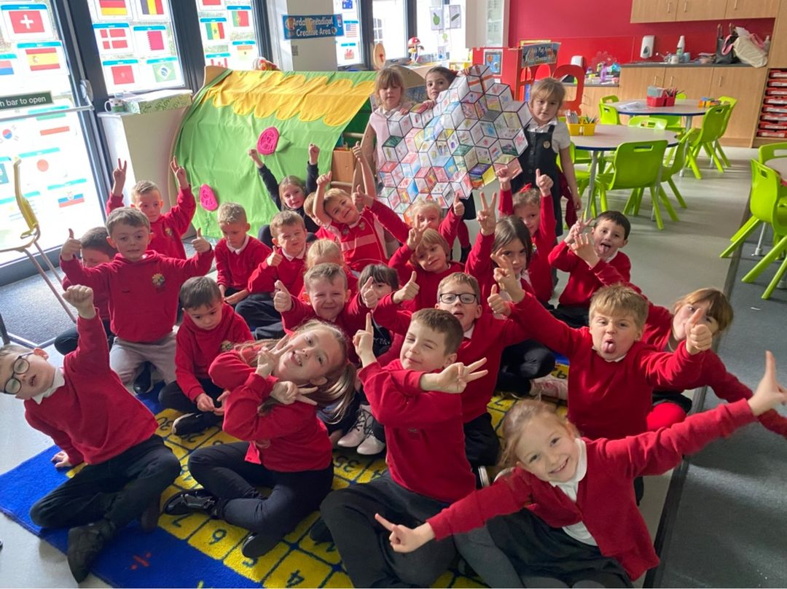

***Helpline Support***

*Family lives: Offers a confidential and free helpline service for families in Wales on any aspect of parenting and family life. To speak to someone call* ***0808 800 2222 or*** *visit* [***Parenting and Family Support - Family Lives (Parentline Plus)***](https://www.familylives.org.uk/) *to access the live chat.*

*Parent Talk Cymru (Action for Children): Offers a free and confidential live chat with a parenting coach available in English and Welsh. Visit* [***Parent Talk - Cymru - Support for Parents from Action For Children***](https://parents.actionforchildren.org.uk/parent-talk-cymru/)*.*

**No booklet can answer every question, so please do not hesitate to call into the office if you cannot find the information that you may need. We are more than happy to answer any queries you may have or signpost you to other services that may provide help and advice.**

..