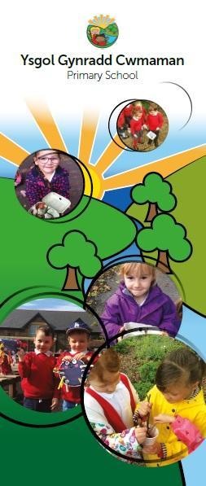

**Child Development 0-4years**

**Information booklet**



**Cwmaman Primary School**

Headteacher – Mr. P Morgan

Glanaman Road,

Cwmaman,

Aberdare.

CF44 6LA

Tel: 01685 661001

Admin.Cwmamanprimary@rctcbc.gov.uk

An overview of Child Development.

Understanding more about your child’s development may help you understand your child and their behaviour better.

Smiling for the first time, holding a toy, crawling, taking a first step and saying their first words are called developmental milestones. These are the things most children can do by a certain age. Most children’s development follows a similar pattern, although the timing of when certain milestones are reached will vary from child to child. Disabled children or children with additional learning needs may take more time to reach the different stages. If you are worried about your child’s development – ask your GP or health visitor.

Don’t try to compare your child to anyone else’s. This will put pressure on you and your child. All children are unique. Every child will develop at their own pace and in their own way. They will reach the different development stages at different times. They will also react differently to things around them, depending on their personality or temperament.

The way your child behaves is part of growing up. A lot of the behaviour you find difficult may be perfectly normal for your child's age and stage of development. Try to enjoy and celebrate your child’s changes and adapt to them.

Here is some general information about the different stages of development and some tips to encourage and support your child.

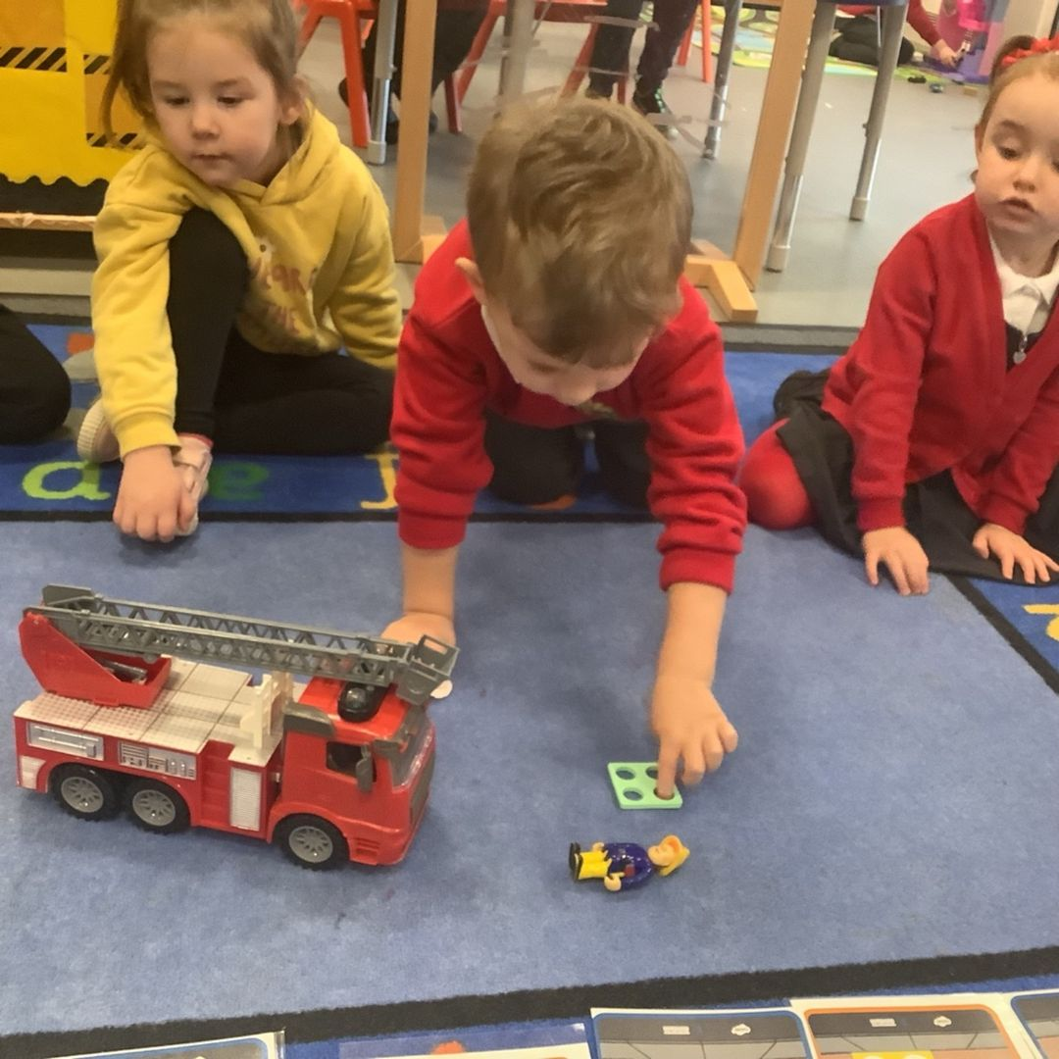 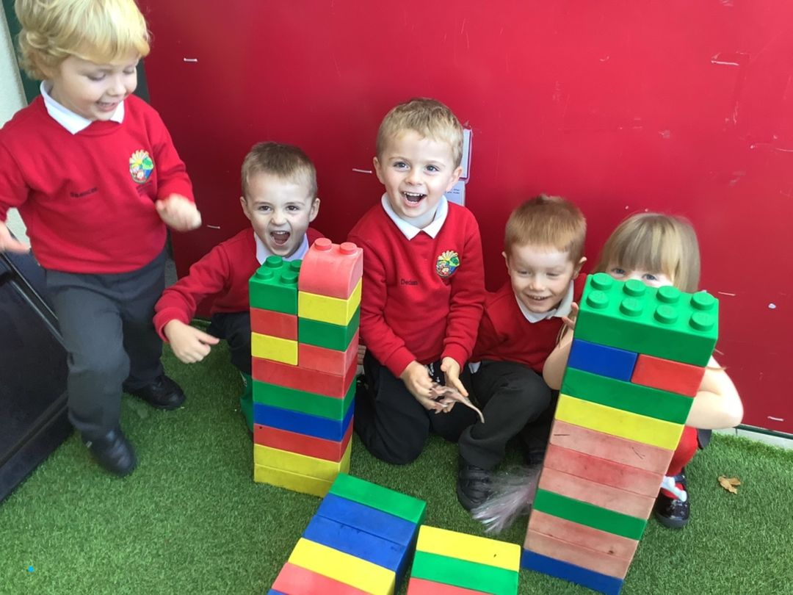

# Your child 3-5 years

**Your child is becoming more independent and capable of doing things on their own.**

Your child is becoming more independent and capable of doing things on their own. They are at the beginning of learning how to get on with others, and can control their feelings better (although they may still have the odd tantrum).

At this stage your child is moving out of babyhood into childhood. Try to be patient as your child builds new skills. Although your child is getting very independent they still need lots of hugs and encouragement from you. When you praise your child and give them lots of positive attention it builds their self-esteem and helps them to learn.

The following information provides information about the stages of your child’s development and some tips for what you can do to support your child. Your child may do some things earlier or later than described here.

If you are worried about your child’s development – ask your health visitor, GP or Foundation Phase setting/school.

### Between 3-4 years your child may:

* Like to play with other children and friendships are becoming more important.
* Talk well in sentences and talk clearly enough to be understood. (If your three-year-old is hard to understand, mention this to your GP or health visitor).
* Ask lots of questions.
* Talk with other children when playing.
* Draw a recognisable person with a face and maybe arms and legs. This will depend on how much practice and encouragement they get.
* Eat independently.
* Put on and remove their clothes
* Like to play pretend games and understand simple rules in games like hide and seek.
* Be able to recognise and express different emotions

**Between 4-5 years your child may:**

* Talk well and be understood by most people.
* Have developed fine motor skills like using scissors and buttoning up small buttons.
* Be able to produce pictures and symbols.
* Know the names of primary colours and can match them.
* Have developed gross motor skills like running, jumping, skipping and climbing.
* Play confidently with balls and be able to throw, kick, bounce and catch.
* Play cooperatively with other children.

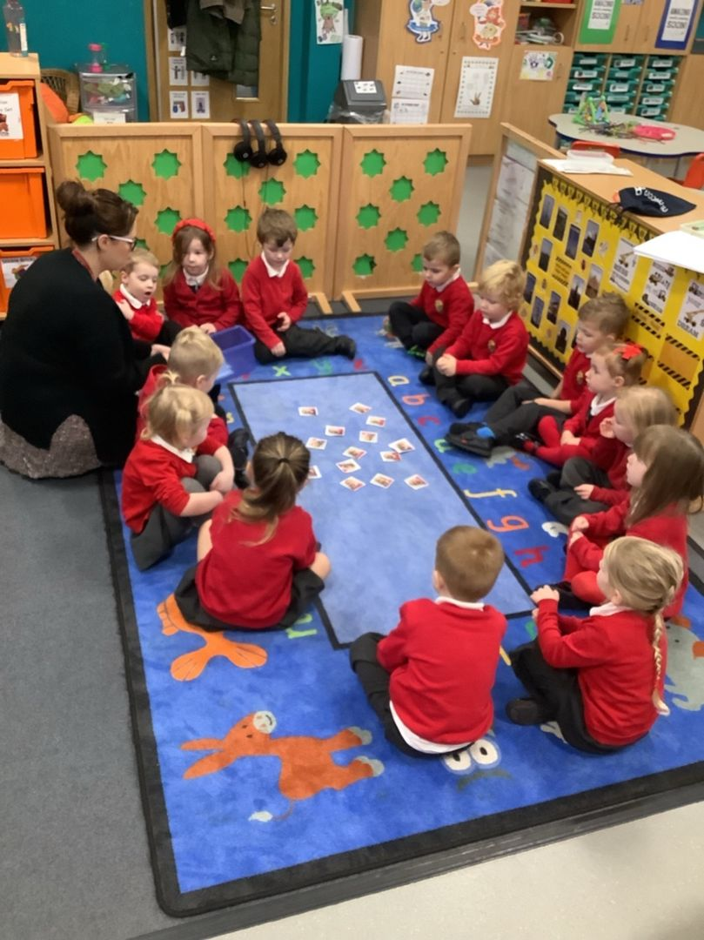

Ten tips to help you support your child's development

### 1. Simple, regular routines

These will help you and your child feel more secure. Routines will help structure your day from start to finish. You will need to plan ahead for the next day and week but keep it simple and doable – getting up time, meals, bath time, exercise, and going to bed.

### 2. Talk about what you’re going to do

Talk about and explain to your child what you are going to do throughout the day. Help them take turns in conversation. Tune into what they already know and build on their daily routine. Be a running “commentator” and keep your language simple. Draw pictures, show pictures or use objects to show what you are going to do if your child needs more help to understand. If you have them, use photos of friends and/or family to talk about people that are important to you in different households.

### 3. Enjoy your time together

Have fun, we learn best when we are enjoying what we do. If you or your child are not enjoying something, stop and change your plan. Try to make sure you do something fun for you and your child every day, more than once if you can.

### 4. Selectively use devices

Use the TV and/or other devices, but choose when you are going to watch and what you are going to do. CBeebies and S4C's Cyw have some fun programmes. Use your phone/other devices to record what you have done – kicked a ball, learnt a new song or a new word. Turn off the TV when you are not watching it so there is not a constant stream of information.

### 5. Use what you have at and near your home

You don’t need to buy extra things. Walk in your garden or near home, point to flowers, birds and trees, buildings and everyday objects and name them. Play walking, running and finding games. Do a treasure hunt for everyday objects in your home/garden. Teach your child a new song or nursery rhyme. Play catch, or rolling a ball backwards and forwards. Use mirrors in the bathroom to encourage copying and taking turns – making silly faces. Children like to repeat familiar activities. You are your child’s first and lasting teacher – you can help them learn and grow so much. They can also teach you - look at how they learn best.

### 6. Let your child join in and help as much as they can with household tasks

Cleaning, cooking, fixing. If they can’t help, they can watch you and you can tell them what you are doing. If you have older children, they may be able to help by talking with and/or entertaining younger siblings.

### 7. Create a safe, quiet place for your child to be quiet

A cocoon. Create the same for yourself. Put your phone in the drawer and check at set intervals only (not too often). Acknowledge your worries, ask for help/advice if you need it and let your child ask for help. Practise relaxing and deep breathing.

### 8. Let your child talk and ask about COVID 19 and other things that may be worrying them

Covid 19 is still around us and if your child wants to talk about it please tell them the facts very simply. They may also be worried about the war in Ukraine or having enough money. Let them tell you about their worries, however small or big.

### 9. Keep in touch with your family and friends

This could be on a daily basis or a few times a week either face-to-face, or by FaceTime/Skype/WhatsApp if they live away. Start by saying “Hello” and finish by saying “Goodbye”. Tell or show your family one thing your child has done well or learned. Decide what you will share/do, sing a song or do a dance. If you need a longer chat for yourself ring later when your child is asleep, if you are not too tired!

### 10. Celebrate achievements

At the end of each day, think of one particularly positive thing that you and your child have achieved and enjoyed that day. Tell them, talk about it and record it in some way and celebrate it.

**Time to notice the good things about me**

Children learn about themselves through their relationships with their parents and carers. When you praise, you are teaching your child about their worth, how to be proud of themselves and are raising their self-esteem.Research has shown that children who are close, and have a good supportive relationship with their parents have higher self-esteem and are more successful in school and beyond. You can do this by:

* Giving your child genuine praise when you see a positive behaviour, with words, a shared look, a smile, thumbs up or another gesture, a hug or positive touch.
* Showing genuine enthusiasm when you give a compliment, smile and look at your child. Your child can tell if it’s not genuine. If you don’t feel you can be genuine in your praise, instead you could say *“Tell me more about your drawing/what you have made….”* and spend time learning about it. You might then find yourself saying “*It’s brilliant how excited you were to make that.”*
* Letting them know what made you happy or proud, e.g. *“Thank you for picking that up”.* This helps your child learn what behaviour you like to see.
* Giving your child praise when you feel proud of them or when you see a desirable behaviour. This helps your child learn what positive behaviour looks like. Reward the behaviour with attention, praise, cuddles and favourite activities.
* Making it clear and specific to your child what you are praising. It will show you were paying attention and that you really mean it. Instead of saying *“Well done”* say *“I loved the way you shared your doll with your sister.”* Praise is more powerful when you make it clear what you are praising your child for.
* Using your child’s name positively – “*Wow, Ben, you’ve worked so hard at that! I’m impressed”*. Sometimes you forget to use names in a positive way and you don’t want your child to only hear their name when they are being called in a negative way.
* Noticing your child just for being who they are. Praise doesn’t always need to be used to encourage a certain behaviour. There is nothing better than seeing a child’s face light up when you say thank you. For example, *“Thanks for letting me play shopes with you, you are such a fun person to play with”.*
* Letting your child “overhear” you talking positively about them too. *“Daddy, did you know that he was really kind to his friend today when he….”*
* Noticing a child’s effort as well as the outcome e.g., *“You tried so hard to put your socks on, I am really proud of you trying like that”*.
* Wanting your child to learn and grow for themselves, not by comparing themselves to others. Success doesn’t need to be competitive. Your child can be praised for who they are, without comparing them to others.
* Praising the things they can control, change or do again rather than things that are outside of their control.
* Thinking about your child – some children would rather a quiet comment or look, others enjoy something louder and more showy – learn what makes your child comfortable.
* Praising works best when you give it as soon as the behaviour has happened.
* Looking for times when your child behaves the way you want. Tell your child why you are pleased and what you liked about their behaviour.
* Showing appreciation and love through words and affection. Your child will learn to talk and act based on how you talk to them and how you treat them.
* Don’t wait for your child to do something perfectly to praise them. Praise your child for trying as well. If you praise effort, it teaches your child to keep learning and keep trying.

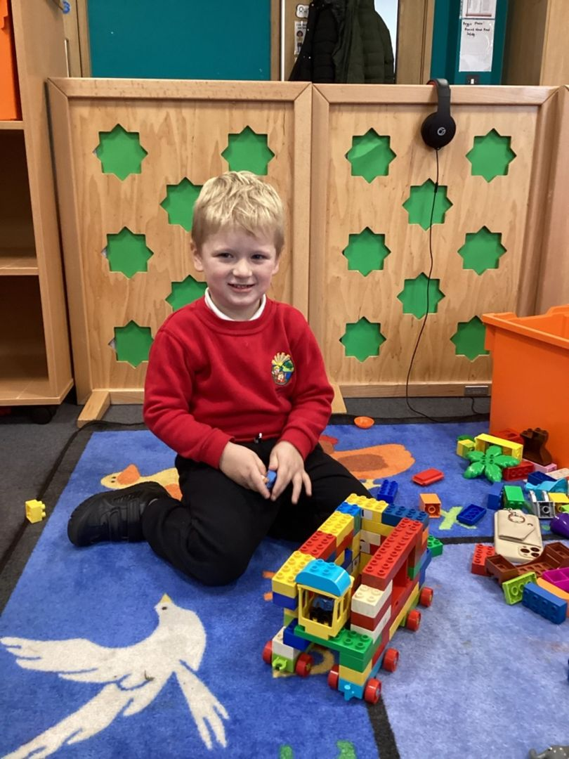

***Helpline Support***

*Family lives: Offers a confidential and free helpline service for families in Wales on any aspect of parenting and family life. To speak to someone call* ***0808 800 2222 or*** *visit* [***Parenting and Family Support - Family Lives (Parentline Plus)***](https://www.familylives.org.uk/) *to access the live chat.*

*Parent Talk Cymru (Action for Children): Offers a free and confidential live chat with a parenting coach available in English and Welsh. Visit* [***Parent Talk - Cymru - Support for Parents from Action For Children***](https://parents.actionforchildren.org.uk/parent-talk-cymru/)*.*

**No booklet can answer every question, so please do not hesitate to call into the office if you cannot find the information that you may need. We are more than happy to answer any queries you may have or signpost you to other services that may provide help and advice.**

..